**Green Society Public School**

**D-20**

**Ratnanagar-7, Sauraha, Chitwan**

**First Terminal Examination-2082**

**Class: L.K.G Time: - 2 hrs. F.M.: 50**

**Sub: English P.M.: 18**

|  |
| --- |
| **Name: Roll No.: Sec.:** |
| **­­­­­­­­­­­­ ________________ ______________ OBT.MARKS:**  **INVIGILATOR EXAMINER** |

1. **Circle the ‘at’ family words. [4]**

1. 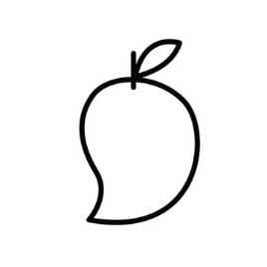**Write the first letter of the given pictures. [5]**

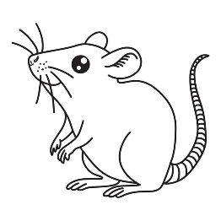

1. **Write the small letter of the given letter. [6]**

**D ______ M ______**

**E ______ Q ______**

**H ______ R ______**

1. 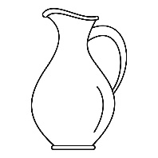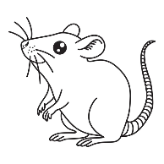**Write the missing letter in each word. [5]**

**H____t R____t J____g**

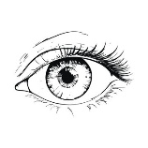

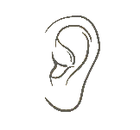

**E____e E_____r**

1. **What comes between. [5]**

**b______d**

**m_____0**

**e______g**

**s______u**

**i______k**

1. **Match the letter with given picture. [6]**

**Cc** 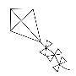

**Ii** 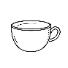

**Kk **

**Mm **

**Pp** 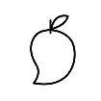

**Ss** 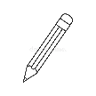

1. **What comes after. [6]**

**F _____ T _____**

**J _____ V _____**

**N _____ Y _____**

1. **Make word from the given pattern. [6]**

**____________________**

**____________________**

**____________________**

**____________________**

**____________________**

**____________________**

1. **Fill up the missing letter. [7]**

K _____ m ______ o ______ q _______ s

t ______ v ______ x _______ z

**The End**